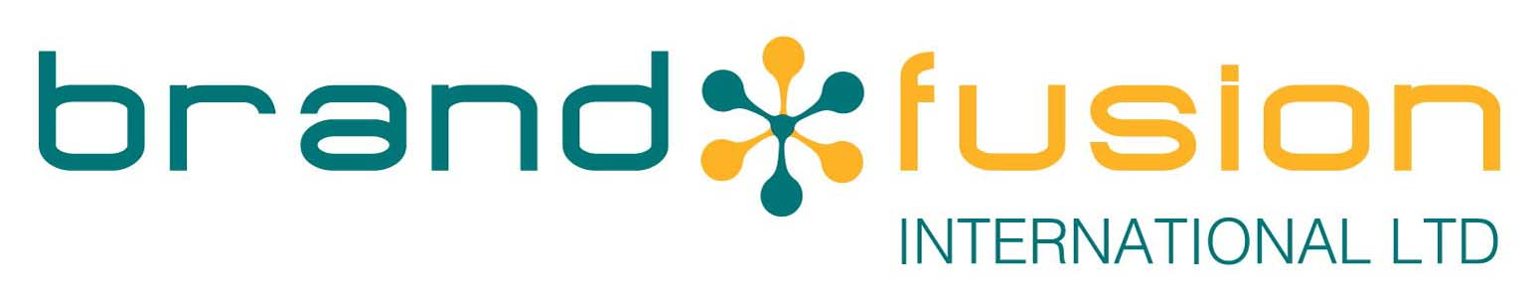

BRAND FUSION PAYMENT TERMS AND CONDITIONS
This document outlines the procedures, terms, and conditions regarding payments made by customers (“the Buyer”) for products (“Goods”) supplied by Brand Fusion International Ltd (“the Company”).
These payment terms should be read in conjunction with our full Terms and Conditions of Business, available at www.brandfusion.co.uk, or on request via email to sales@brandfusion.co.uk.

Note: These terms may change. Buyers are responsible for reviewing the latest version.

Payment Terms
As part of the Company’s commitment to reducing environmental impact and helping our Buyers do the same, all invoices and statements will be sent electronically.
Payment due date
  - Direct Debit: 25 days from end of month
  - Non-Direct Debit: 30 days from invoice date
It’s important that the Buyer informs the Company as soon as possible if there are, or there are expected to be, any issues with making a payment; in particular if any due payments are missed.
The Company reserves the right to charge interest on overdue payments in accordance with the Late Payment of Commercial Debts (Interest) Act 1998, or, if no statutory rate applies, at 4% per month above the Barclays Bank Plc base rate, calculated from the due date until full payment is received in cleared funds.
All prices quoted are exclusive of VAT, which will be applied in accordance with the Value Added Tax Act 1994 or any future legislation.
Where Direct Debit or other methods of payment are returned unpaid or are unpresented by the Company’s bank, a £20.00 administration fee will be applied per occurrence. Separate bank charges may also apply.

Preferred Payment Method: Direct Debit
The most efficient way for the Buyer to settle their account with the Company is via Direct Debit.

Benefits of Paying by Direct Debit
- Discount: Payment by Direct Debit will immediately give the Buyer a 2% discount on all Goods purchased.
- Convenience: Payments are automatically taken care of - no need to remember due dates or set reminders.
- Peace of Mind: With a fixed schedule, the Buyer will never miss a payment or face late fees.
- Timesaving: Once set up, there's no need for monthly admin or manual transactions.

- Secure and Protected: By the Direct Debit Guarantee
- Environmentally Friendly: Reduces paper waste with statements sent electronically.
- Improved Budgeting: Easier to manage finances with predictable payment dates.

Direct Debit Set Up

The attached Direct Debit Mandate must be completed in full, signed and returned by post to:

Brand Fusion International Ltd
Dorset House, Regent Park
Kingston Road,
Leatherhead
Surrey KT22 7PL

- Direct Debit Mandates sent by email or photocopies sent by post WILL NOT be accepted.
- The amount to be taken will be notified to the Buyer by email approximately 10 working days in advance.
- Collections occur on the 25th of each month or nearest working day.
- Buyers must whitelist accounts@brandfusion.co.uk This prevents important emails from being mistakenly categorised as spam and potentially missed.

Alternative Payment Options
If nearing credit limits or following a failed Direct Debit, interim payments can be made via BACS (allow 3 working days for clearance). Please contact our accounts department for bank account details.

Online Payment
The Buyer can log into their account at www.brandfusion.co.uk and select the invoices to be paid. Payment is processed securely via SagePay, using a debit or credit card.

Credit Card (excluding American Express)

Credit card payments as well as other methods of payment, are accepted by phone. To make a payment or for any account-related queries, please contact our Accounts Department on 01372 373237, option 2.
Note: A 2% charge may apply to credit card payments made more than 28 days after the invoice date.

